Name : Abubaker Attique

Class : 5-A

Roll no : P20-0560

Lab 01

**Task 1 :**

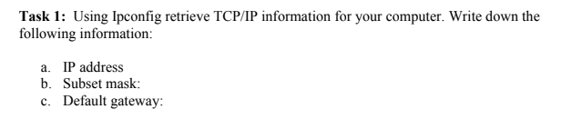

**SOLUTION : (Wireless)**

Open command prompt and then write ipconfig and then press enter you will find the detail about your network just go to Wireless Lan Adapter here you will see Ipv4 Address , subnet Mask , And default gateway.

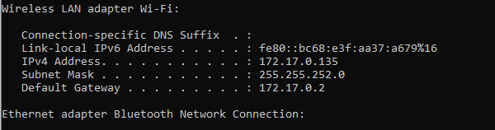

Ipv4 Address……………………………………………..172.17.0.135

Subnet Mask…………………………………………….255.255.252.0

Default Gateway……………………………………….172.17.0.2

====================================================

**Task 2:**

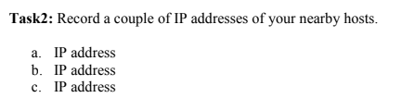

**Solution :**

a) 172.17.0.114 (Razz )

b) 172.17.0.78 (Sharif)

c) 172.17.1.156 (Awais)

====================================================

**Task 3:**

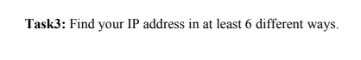

**Solution :**

1. Ipconfig (WIRELESS)

Open command prompt and then write ipconfig/all in command prompt and press enter

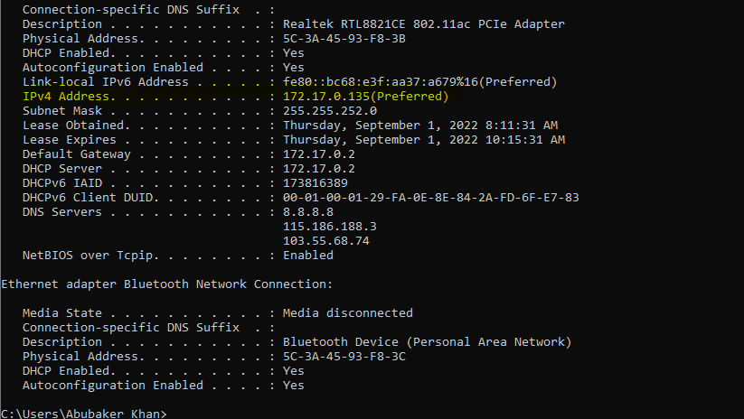

------------------------------------------------------------------------------

1. **Setting App (WIRELESS)**

Open wifi then click on the way with which you are connected

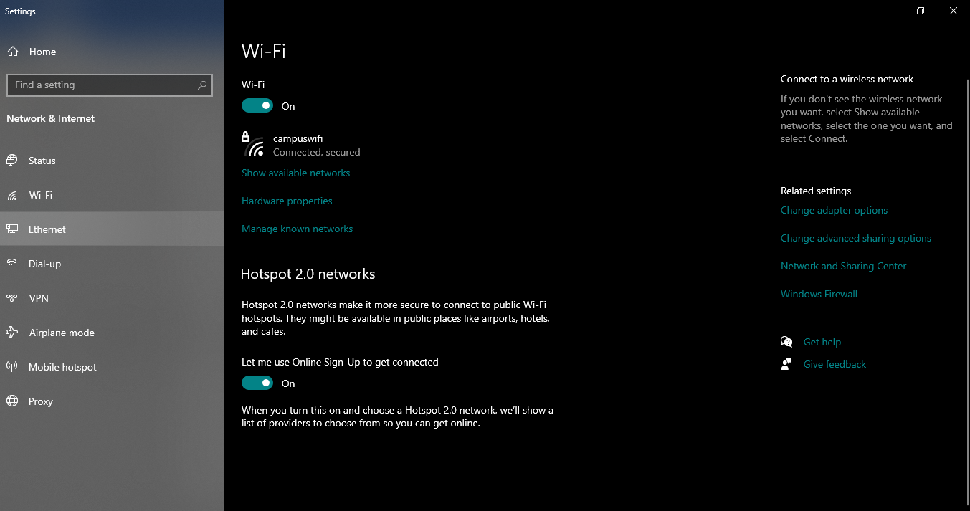

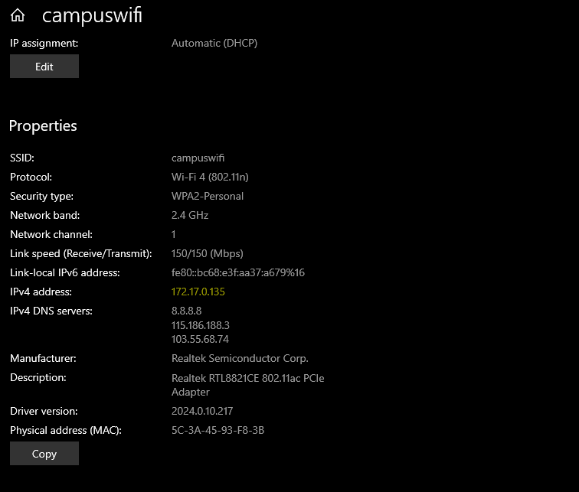

IPv4 address 172.17.0.135

------------------------------------------------------------------------------

1. **Change Adaptor setting (Wireless)**

Open control panel then click on network and sharing and then click on wifi detail you will see the ip address there.

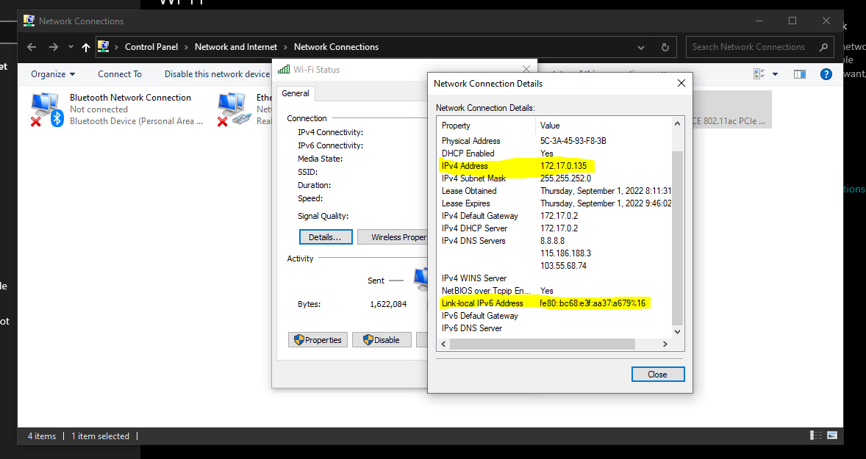

1. **System Information (Wireless)**

Open System Information in your computer then expand components then again expand network then click on adaptor.

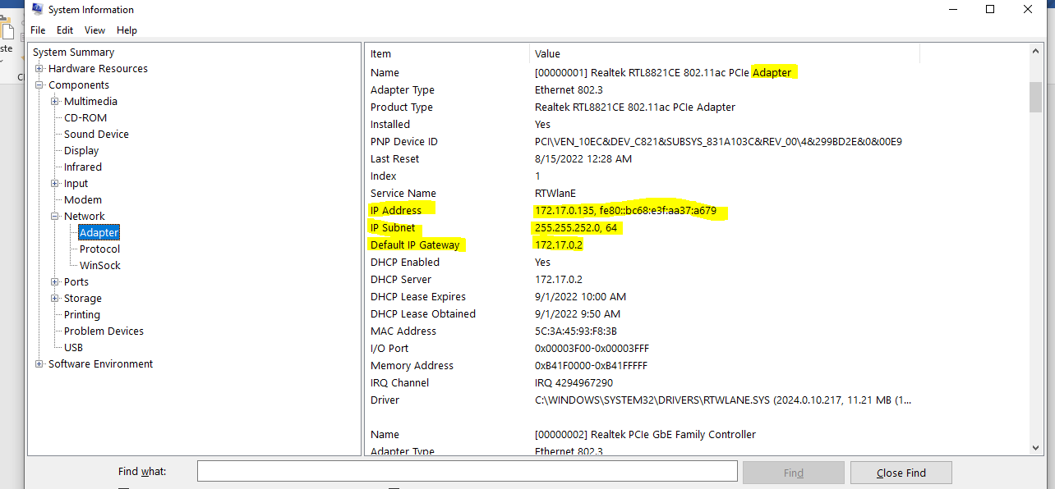

IP Address 172.17.0.135

IP Subnet 255.255.252.0

Default IP Gateway 172.17.0.2

------------------------------------------------------------------------------

1. **PowerShell (Wireless)**

In powershell write gip and then press enter

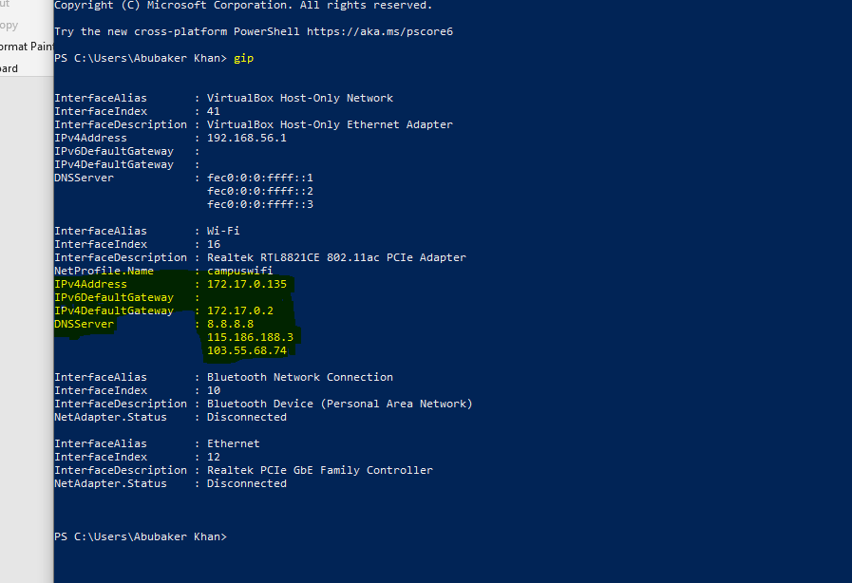

IPv4Address : 172.17.0.135

IPv6DefaultGateway :

IPv4DefaultGateway : 172.17.0.2

DNSServer : 8.8.8.8

115.186.188.3

103.55.68.74

------------------------------------------------------------------------------

1. **Finding ip address in Task manager (Wireless)**

Open task manager and then click on performance and then click on wifi you will see ip address

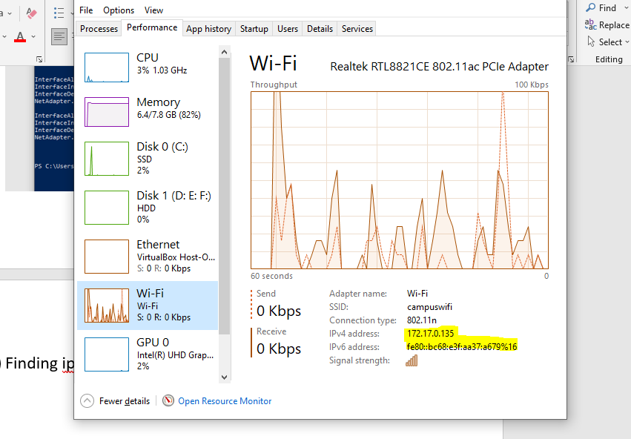

IPv4Address ……….. 172.17.0.135

IPv6Address………….fe80::bc68:e3f:aa37:a679%16

**THANKYOU !!**